Zero Tolerance policy – Patient Behaviour

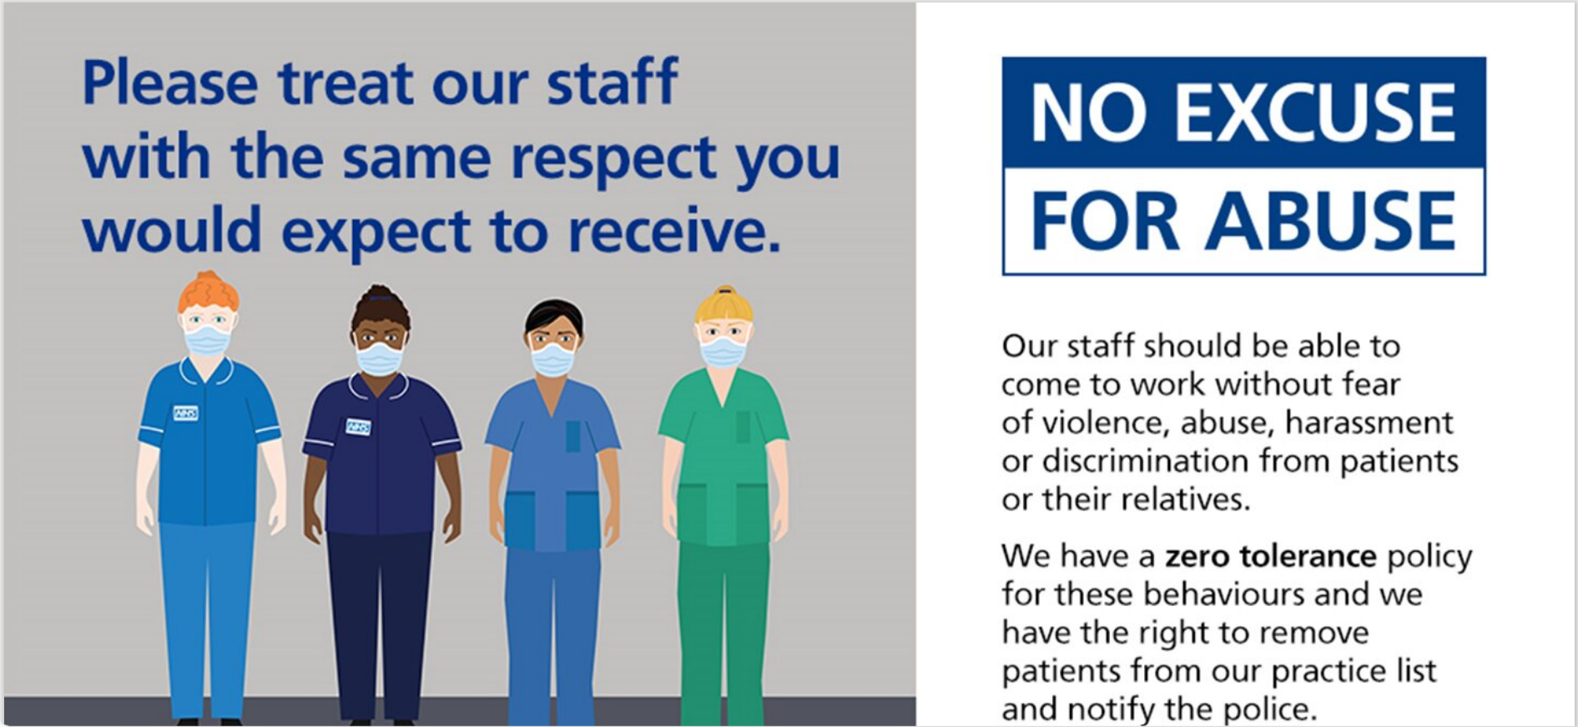
As an employer, the practice has a duty of care for the health, safety, and wellbeing of its staff. The practice also has a legal responsibility to provide a safe and secure working environment for staff. Staff mental health is as important as their physical health.
All patients and staff are expected to behave in an acceptable, respectful manner.
The practice follows the NHS guidance concerning Zero Tolerance and has comment and complaints policies in place should patients want to discuss any care related concern or issue they feel they have or are experiencing.
Any incident in which an employee is abused, threatened, or assaulted in circumstances relating to their work is unacceptable and not tolerated.
This includes the serious or persistent use of verbal abuse, aggressive tone and/or language and swearing/foul language. It also includes any type of sexual harassment
Staff should not be left upset and distressed following an interaction with a patient.
All instances of actual physical abuse or threatening behaviour towards any doctor, member of staff, other patients, or practice premises, by a patient or their relatives will be reported to the police.
We expect all patients to be responsible and avoid attending the surgery under the influence of alcohol or illegal drugs. Any alteration of prescriptions is illegal and will not be tolerated.
The General Medical Council states In Good Medical Practice that: “In rare circumstances, the trust between you (the Practice) and a patient may break down, and you may find it necessary to end the professional relationship. For example, this may occur if a patient has been violent to you or a colleague, has stolen from the premises, or has persistently acted inconsiderately or unreasonably.”
This includes unnecessarily persistent or unrealistic service demands that cause disruption. Examples of this include, but are not limited to:
- Demanding to only speak to a specific team member. Not all staff work full time so calls will be allocated based on urgency and clinical/need.
- Refusing appointments with an appropriate clinician for the presenting care need i.e. insisting on a GP appointment when seeing a pharmacist or nurse prescriber is most appropriate to meet your clinical need or refusing to see an available GP for your presenting care need when your preferred GP is unavailable. As a patient you have the right to request to see a specific clinician or to every effort will be made to accommodate this request but there may be instances where this is not possible as we triage all requests based on clinical need.
- Refusing to access the service in the appropriate manner i.e. sending emails/texts instead of using the NHS Digital approved digital consultation service.
- Demanding a same day appointment for a routine clinical need – this deprives access to urgent care services for those who genuinely need it. Lincoln House Surgery operate a triage model for access which is based on clinical need.
- Contacting individuals directly via social media or personal email instead of through the practice contact channels

The practice has a finite number of available appointments, and you may be directed to a clinician who is not a GP, or your preferred GP, but who is appropriately qualified to manage the presenting care need. We provide a named GP service, but we cannot always accommodate requests to speak to the same GP due to high patient demand for appointments.
If you are seriously unhappy with the quality of service, you have the right to register with another practice without notifying us. Similarly, on the very rare occasions when a patient breaches this policy, we have the right to remove the patient from our Practice list.

Examples of Unacceptable Standards of Behaviour
In exceptional circumstances, a breakdown may occur between a doctor and their patient. If the breakdown is of a serious nature e.g. serious physical or verbal abuse to any member of the practice team, the doctors may feel that the doctor/patient relationship has been compromised. Steps may be taken to have the patient removed immediately from the practice list. Where possible, conciliation would always be the preferred route. Reasons for removal will be given in writing.
Where we deem an incident is not serious enough to warrant immediate removal, we will issue a first and final warning.
You will be removed from our patient list immediately if your behaviour has meant we needed police assistance or have made a report to the police.
The following are example of when you may be issued with a first and final warning or removed from our patient list dependent on the severity of the incident.
- Violence.
- Excessive noise eg recurrent loud or intrusive conversation or shouting.
- Threatening or abusive language involving swearing or offensive remarks.
- Racial or sexual remarks.
- Aggressive, forceful tone and/or language that upsets staff.
- Malicious allegations relating to members of staff, other patients or visitors.
- Offensive gestures or behaviours.
- Abusing alcohol or drugs on practice premises.
- Drug dealing on practice premises.
- Wilful damage to practice property.
- Threats or threatening behaviour.
- Theft.
- Persistent and/or unrealistic demands on the service
- Repeated derogatory comments about the practice or individuals either verbally, in writing/digitally or on social media platforms.

This list is not exhaustive and there may be other occasions where we have cause to issue a warning or remove you from our patient list.
If you are unhappy with the practice, we have a complaints procedure to assist you, or you have the choice to register with another practice – there really is no need for unpleasant behaviour with these options available to support you.
We trust this policy is clear and supports a mutually respectful environment for patients and staff.
Thank you for your support.

Date of review: April 24 Date of next review: April 26

